## **PONDERFUL Task 1.5 – Sustainable Finance Workflow – Demosite SPAIN, LA PLETERA**

## 1.a. Who? Describe pondscape developer, land-ownership, project manager

**Main contact**: Diego Pereira [dplponderful@gmail.com](mailto:dplponderful@gmail.com) and Francisco Javier de Quintana Pou [xavier.quintana@udg.edu](mailto:xavier.quintana@udg.edu)

**Ownership**: The land is publicly owned and protected as a Partial Natural Reserve. The land is owned by the state under the Spanish coastal law [Ley de Costas], which holds that all terrains affected by sea flooding must be publicly owned. The land had been partially developed before the financial crisis of 2008 lead to a ceasing of the private development, after which the saltmarsh was ecologically restored.[1] Since 2010 the land is included in the Montrigí Natural Park as a Partial Reserve.

**Project management**: LIFE Project that restored ecosystem was coordinated by the local municipality Torroella de Montgrí Municipality. The project also featured University of Girona, the regional government and natural park (Generalitat de Catalunya – Parc Natural del Montgrí, les Illes Medes i el Baix Ter), and an engineering company (Empresa de Transformació Agrària – TRAGSA)[2].

## 1.b. What? Describe current pondscape NbS and context

Overarching description and key data:

* NBS type: New pond creation, former pond restoration
* Location: La Pletera is located in Torroella de Montgrí-l´Estartit (Girona), Catalonia, Spain.
* Pond #: 20 ponds
* Pondscape surface area (km2): 0,6
* Water surface area in the pondscape (km2): 0,33
* Level of protection: The entire area is protected as a Partial Natural Reserve (Reserva Natural Parcial), which constitutes a higher category of protection than Natural Parks.
* Mediterranean bio-climatic zone
* Nature’s Contributions to Peoples (benefits):

- Place regeneration

- Health and wellbeing

- Biodiversity enhancement

- Climate resilience

- Knowledge and societal capacity building for sustainable transformation

* Land use: Built coastal environment, agricultural land use, coastal marshes

Lead by the Torroella de Montgrí Town Council, the main objective of the LIFE Pletera project was the reconstruction of the salt marsh system (in which the coastal lagoons are a key element) and the restoration of its ecological functionality, which was altered by abandoned infrastructure, a promenade, and streets. The actions planned in order to achieve this goal were the deconstruction of the built-up areas and the restoration of the previous wetlands and their ecological functioning. The objective of the project included developing a good response to climate change (sea level rise and more storms) and to restore the ecological functioning of the entire system, over both short and long term.

The second objective of La Pletera is the dissemination of the results. On the one hand, the project seeks to demonstrate, both to the local population and to tourists, the importance of the conservation of these ecosystems in order to recover the ecological functioning. On the other hand, the project seeks to demonstrate how an area that has been critically harmed by the urban expansion can still be restored ecologically. The third objective is the increase of the capacity of carbon fixing of the coastal systems and the reduction of CO2 emissions.

**Specific NbS actions** *Break-down of specific actions, technical and non-technical measures to implement the NbS*

|  |  |
| --- | --- |
| Planning | A1. adaptation of the construction project and arrangement of accesses |
| A2. topographic update and underground circulation map |
| A3. revegetation preparation and support tasks |
| Technical measures | C1. Correction of affected services |
| C2. Creation lagoon system |
| C3. Improvements |
| C.4 dune system restoration |
| C.5 itineraries and arrangement of accesses |
| Maintenance | Ongoing maintenance of infrastructure |
| Monitoring | D.1 ecological status monitoring |
| D.2 vegetation monitoring |
| D.3 monitoring water levels and salinity |
| D.4 Carbon balance |
| D.5 Fish (Fartet) monitoring |
| D.6 Socio-economic impact monitoring |
| Outreach | E.1 Actions to raise local awareness |
| E.2 Demonstration project |
| Project management | F.1 Project Management |
| F.3 Engagement actions with other projects |

**Benefits**

|  |  |  |
| --- | --- | --- |
| Habitats and biodiversity | Aquatic plant species richness (submerged, floating, helophytes), including Charophytes | 3 |
|  | Water bird species richness (nesting, mating, overwintering) | 104 |
|  | Amphibian species richness | 3 |
|  | Dragonfly species richness | 1 |
|  | Number of families of invertebrates belonging to Ephemeroptera, Plecoptera, Trichoptera, Odonata, Coleoptera and Gastropoda. (aquatic stages) | 10 |
|  | Number of species of invertebrates belonging to Ephemeroptera, Plecoptera, Trichoptera, Odonata, Coleoptera and Gastropoda. (aquatic stages) | 30 |
|  | Number of conservation priority species (N) | 3 |
|  | Conservation score : total value for the pondscape | 60% |
|  | Number of non-native species introduced | 33 |
|  | Number of invasive alien species (N) | 5 |
|  | Proportion of regional species richness (for each taxonomic group whose species richness is measured) | 30% |
|  | Total surface of water (ha) | 0,33 |
|  | Dragonfly species richness | 3 |
| Pollination | Number of  pollinator species | 1 |
| Climate regulation | Capacity of C storage in the ponds (by primary production, by organic matter accumulation) (gC /m3 /y) | -270 |
| Net carbon removed or stored in vegetation and soil (t CO2e/pondscape/y) | 337 |
| Physical and psychological experience | Number of persons frequenting the  pondscapes (leisure, tourism, fishing, nature watching, …) (nb/year) | >60.000 |
| Area inside the pondscape accessible to the public | 10% |
| Self-reported satisfaction/wellbeing (scale) | 7,95 |
| Physical and psychological experience | Number of studies driven for acquisition of knowledge (nb/year) | 0,6 |
| And, if data are available: Number of artistic productions Number of mobilised animators of environmental education Citizen involvement in environmental education activities (N of people) | 5 |

**Pressures:**

Climate change (major pressure): Sea level rise and higher intensity in flooding episodes.

Traffic and overcrowded parking lots during summer (minor pressure): Tourism puts pressures on local communities and their infrastructure and increases littering.

## 2.a. Scenarios

*Concrete description of the different scenarios considered for financing.*

Scenario 1: No actions taken. No costs. Site will slowly deteriorate.

Scenario 2: Maintain existing site. Ongoing maintenance costs. Site will continue to deliver current level of benefits and ecological functions.

Scenario 3: Expansion In addition to maintaining existing site, expand existing site by 21ha. Large NbS creation costs as well as ongoing maintenance costs. Site will deliver additional benefits and ecological functions (on the expanded area), such as new temporary ponds (during flooding events) and new permanent ponds on the lowest points of the newly restored salt marches. This would come in addition to the current level of benefits and ecological functions on the existing area.

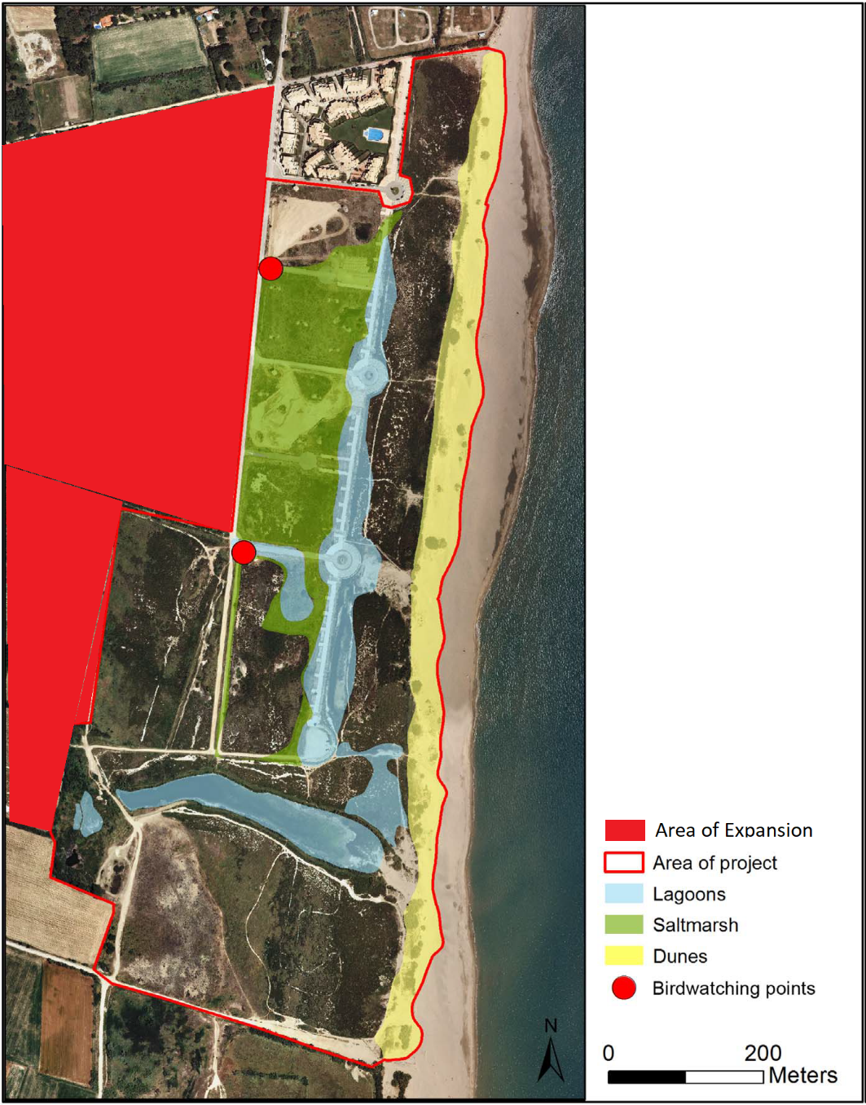

Figure 1 Map of current site and scenarios (from Pueyo-Ros et al 2018)

|  |  |  |  |
| --- | --- | --- | --- |
|  |  | Scenario 3: Expansion (scenario 2 + expansion) | |
|  | Scenario 1: No action | Scenario 2: Maintain current NbS | Expansion to additional 21ha |
| Planning | None | None | * A1. adaptation of the construction project and arrangement of access[3] * A2. topographic update and underground circulation map * A3. revegetation preparation and support tasks * Land purchase/rental agreement[4] |
| Technical measures | None | None | * C2. Creation closes system[5] * C.5 itineraries and arrangement of accesses |
| Ongoing maintenance | None | * Maintain infrastructure * Revegetation of dunes, river Ter mouth, walkways * Installation of sand traps * Cleaning | * Maintain infrastructure (on expansion) * Revegetation of walkways (on expansion) * Cleaning (on expansion) |
| Monitoring | None | * Minimal socio-economic monitoring * Minimal monitoring (water bodies, species, invasive species, habitats, and dune morphology) | * Increased socio economic and environmental monitoring for existing and additional area.[6] |
| Outreach | None | * Managing education programs * Guided visits * Communication and outreach | * E.1 Actions to raise local awareness [7] |
| Project management | None | Minimal | * F.1 Project Management |

Expenses related to the different activities of the three scenarios are based on discussions with experts from the University of Girona[8], the previous cost for implementing the La Pletera LIFE Project, and the conservation plan for the site after the Life Project[9].

|  |  |  |  |
| --- | --- | --- | --- |
|  |  | Scenario 3: Expansion (scenario 2 + expansion) | |
|  | Scenario 1: No action | Scenario 2: Maintain current NbS | Expansion to additional 21ha |
| Planning | None | None | €4.942[10] |
| Technical measures | None | None | €104.873€[11] |
| Ongoing maintenance | None | 10.350€/year | 7.245€/year |
| Monitoring | None | 9.150€/year | 6.405€[12]/year |
| Outreach | None | 3030€[13]/year | 17.845€/5 years[14]  = 3.569€/year |
| Project management | None | Minimal | 81.236€/5 years[15]  = 16.247€/year |
| **Total costs** | 0 | No one-off costs  22.530€/year ongoing costs | 109.815€ one-off costs  33.466€/year ongoing costs |

## 2.b. Cost avoidance and reduction

Reducing project costs is one approach to reduce funding needs. For this, it is important to find cost reduction opportunities that do not impair the project’s success or its long term sustainability. Below is a list of a few options that could help to reduce project costs for La Pletara. Each of these points is explained in more detail in the Ponderful financing inventory.

Contracting approach:

* Community asset transfer

Voluntary contributions:

* Volunteering, Citizen Science (?)
* In-kind contributions

Subsidies:

* Tax rebates (where applicable)

Resource pooling, sharing

* Sharing machinery, cars, offices, labour, software packages, consultancies, etc. with other projects or local businesses.

# Section 3: Revenue and funding/financing gap

## 3.a. Revenue options[16]

During the second workshop, the participants identified several income instruments, which could help to sustain La Pletara in the long term. The ideas are listed in the table below. Additionally, some rough estimates for possible revenues are provided.

|  |  |
| --- | --- |
| **Income instrument** | **Possible revenues** |
| Parking fees. Parking fees could also regulate the number of visitors coming, or provide incentives to avoid busy times. | €2 parking fee * 18.000 cars[17] = €36.000 |
| Entrance fees for consolidated areas (la Pletera + Baix Ter) | Share of €1 * 15.000 paying visitor = €15.000 |
| Guided tours under public concessions | 25 tours per year * 10 participants * €5 = €7.500 |
| Concessions for food trucks, bars, cafés, or bike renting businesses. The lessee, moreover, could be made responsible for the maintenance of public services, such as restrooms. | €1.000/month * 6 months[18] = €6.000 |
| Cultivating pasture for cattle ranching as a source of income. The idea is, after an agreement with farmers, 21ha of agricultural land would be restored as “closes”[19]. | 10 sold animals per year * €1.000 profit = €10.000/year |

## 3.b. Funding/finance gap

|  |  |  |  |
| --- | --- | --- | --- |
|  | **Scenario 1** | **Scenario 2 (five years)** | **Scenario 3 (five years)** |
| Funding requirements | 0,- | 5 x 22.530€  = **112.650€** | 109.815€  + 5 x 33.466€  = **277.145€** |
| Parking fees | X | €36.000/year  x 5 years  = **180.000€** | |
| Entrance fees | X | €15.000€/year  x 5 years  = **75.000€** | |
| Guided tours | X | €7.500€/year  x 5 years  = **37.500€** | |
| Concessions | X | €6.000€/year  x 5 years  = **30.000€** | |
| Cattle | X | X | 10.000€/year  x 5 years  = **50.000€** |

This is an example of how revenues can be approximately calculated. We present them as gross values, however, proponents must also consider the costs associated with gathering these revenues (e.g. staff costs to gather fees). Costs are calculated over five years as net present values with discount rates of 3.5%.

# Section 4: Funding/finance

This section identifies potential sources of funding and financing to cover the financing gap for the future scenarios. This information was gathered through expert input and through two stakeholder workshops. In the first workshop, stakeholders identified a longlist of funding and financing options; in the second they developed detailed proposals for four options. Opportunities/barriers were discussed at both meetings.

At the first meeting, the following financing instruments for La Pletera were identified by stakeholders:

* EU, national and local grants
* Direct public funds
* Sectoral subsidies to agriculture (CAP) and other sectors
* Earmarked Touristic tax
* CO2 payments and offsets at local level.
* Private sector direct payments linked to increased value for tourism.
* Donations
* User fees attached to the delivery of certain ecosystem services (education)

These instruments that were identified and discussed as part of a group exercise, were useful for the development of the finance inventory and helped to understand the particular setup in La Pletera. The group also identified the following as the need for financing behind the necessary management actions to achieve the objectives of the restoration/maintenance exercise in La Pletera:

* Ecological restoration maintenance actions
* Maintenance measures to keep the infrastructure to achieve recreational values (road, bird watching hut)
* Maintain existing infrastructure
* Maintain existing communication plans (education programme)

At the second workshop, the group exercises allowed for a deeper understanding of the specific financing instruments that could be put in place. The table below provides a list of the financing instruments identified, an assessment of their suitability and limitations.

|  |  |  |  |
| --- | --- | --- | --- |
| **Instrument** | **Suitability** | **Comments** | **Limitations** |
| User Fees – Parking fees | Medium  Between €2-5 /visitor = 120.000 – costs  Our calculations:  €2 parking fee * 18.000 cars = €36.000 | The (parking) fee could be modulated to penalize stays longer than necessary for the visit and to benefit early-morning visitors to encourage ornithological tourism.  An example close by, at Aiguamölls de l´Empordà Natural Park, next to Montgrí Natural Park, where la Pletera is, the entrance is free, but there is a fee of €5 for a full-day parking. | Questions about management: under municipal or natural park. If the parking service management is under natural Park control, it cannot be free of charge for residents. |
| User fees – Guided tours | Low | Under public concession.  a guided tour with access to areas with more restricted use could be charged. This charge could be increased if there was a visit to a visitors center. To charge entrance, the business unit should be larger than the area of La Pletera. For instance, la Pletera + Baix Ter (Lower Ter river protected areas). It could also charge for parking. | There is a need to assess if the area would attract visitors’ interest. A successful business model for prospective tour operators. Demand from visitors to the area needs to be appraised. |
| Market goods – cultivating pasture for cattle | High | After an agreement with farmers, 21ha of agricultural land could be restored as “ closes”. Pasture meadows typical of l’Empordà´s marshes (where la Pletera is), surrounded by drainage ditches bordered by riparian trees. They are often flooded during periods of rain as they lie on top of small ponds. The rain (or any other source of freshwater) would wash away the salt of such marshes. The area refers to the expansion: the inland area next to la Pletera that is already suffering a salinization process by the salt water intrusion and, because of that, is losing agricultural value. | Attract farmers’ interest. Land acquisition costs challenging. Obtain a competitive price for cattle. |
| Lease | Low | Leasing the parking lot.  Leasing space for restaurant, bars etc  Leasing for bike renting business  Affect existing leases, concessions and fees for conservation. For instance: concessions for bars at the beach; touristic fee; blue zones for parking. | High if the planning is in the context of the whole Natural Park. Little tangible if only la Pletera is considered.  Regulation of the Natural Park´s norms for no-built zones |

# Section 5 Conclusion and financing recommendations

The table below identifies our assessment of financing options for the extension of La Pletera pondscape. Based on our assessment and work with demosite leads and stakeholders, we identify financing instruments used in the past, and those that could be implemented in the future.

|  |  |  |  |  |  |
| --- | --- | --- | --- | --- | --- |
| **Category** | **Instrument** | **Past finance options** | **Notes** | **Future finance option** | **Additional Notes (if relevant…)** |
| Income instruments | User fees | **no** |  | **maybe** | Parking and guided tours |
| Business improvement districts | **no** |  | **no** |  |
| Betterment levies | **no** |  | **no** |  |
| Development rights and leases | **no** |  | **no** |  |
| Sale of market goods | **no** |  | **yes** | Selling pastures for cattle feed |
| Other revenue raising measures | **no** |  | **no** |  |
| Contracting approach (cost reduction/restructure) | Community asset transfer | **no** |  | **no** |  |
| Public private partnership | **no** |  | **no** |  |
| Voluntary contributions | Philanthropic contributions | **no** |  | **maybe** | Corporate sponsorship could be an option (e.g. sponsor a pond) |
| Voluntary beneficiary contributions | **no** |  | **no** |  |
| Crowdfunding | **no** |  | **no** |  |
| Tradable rights/permits and payments for ecosystem services | Payment for ecosystem services | **no** |  | **yes** | Informal agreements with farmers possible about traditional farming practices – cultivating pasture for cattle |
| Voluntary carbon markets | **no** |  | **no** |  |
| Biodiversity offset and habitat banking | **no** |  | **no** |  |
| Water quality trading systems | **no** |  | **no** |  |
| Subsidies | Environmental subsidies | **no** |  | **no** |  |
| Tax concessions | **no** |  | **no** |  |
| Grants | **yes** | Research grant from EC LIFE project | **yes** | EC grants offers opportunities for expansion |
| Debt instruments | (Green) loans | **no** |  | **no** |  |
| (Green) bonds | **no** |  | **no** |  |
| Equity finance | Impact investing | **no** |  | **no** |  |
| Commerical investing | **no** |  | **no** |  |
| Other (please explain) |  | **yes** | Co-financing by university of Girona and central, regional, and local government |  |  |

1. In March of 1998, the Direcció General de Costes changed the limits of the maritime-terrestrial public domain from behind the urban zone, considering the whole area as salt marsh area to be protected under the Coastal Law 22/1988. Thus, it was declared non-urban zone and was included as EIN (Interesting Natural Space). In 2016, the Generalitat approved the areas that were included in the Nature 2000 Network, where La Pletera was included. In 2010, the law for the creation of the Natural Park of the Montgrí, Medes Isles and Baix Ter was approved, with the same limits of the area ES5120016 Nature 2000.
2. University of Girona demonstration project: Deurbanization and restoration of Platera's marsh (2014-2018). http://lifepletera.com/en/
3. The expansion differs from the original LIFE project as there is no urban infrastructure to remove (A1, A2). Nevertheless, we keep these actions in as there will still be some related costs (e.g. access, flooding of agricultural land). We assume that the A1 and A1 costs are per ha 25% of the LIFE Platera costs.
4. Based on discussion with project leads, we assume costs of zero for land purchase/rent.
5. Based on discussion with project leads, technical measure costs will be considerably lower for the expansion than for the original LIFE Platera. Assume zero C1 and C3 costs (corrections, improvements) and that C2 and C5 costs are only 10% of the total technical measures from LIFE Platera costs.
6. We assume double per ha monitoring costs.
7. Same as under LIFE Platera, per ha for E1 and F1.
8. Xavier Quintana and Diego Pereira
9. Quim Pou i Rovira Sorelló & Santi Ramos López. 2019. Plan de conservación After-LIFE del proyecto Life Pletera, available here: http://lifepletera.com/wp-content/uploads/2015/03/Plan-de-conservaci%C3%B3n-After-LIFE_F2_1.pdf
10. 10% of the LIFE Project cost (A1+A2+A3).
11. 10% of the LIFE Project cost (C2+C5).
12. Assume double monitoring costs/ha of post LIFE conservation plan.
13. From post-LIFE conservation plan: A.21+A.19+A.18
14. 1/3 of the LIFE Project costs (E1).
15. 1/3 of the LIFE Project costs (F1).
16. These revenue options were identified by stakeholders at the PONDERFUL La Platera stakeholder workshop, 2022
17. Based on 60.000 visitors/year, of which 30% come by car.
18. Considering a six month main season.
19. The “closes” are pasture meadows typical of l’Empordà´s marshes (where la Pletera is), surrounded by drainage ditches bordered by riparian trees. They are often flooded during periods of rain as they lie on top of small ponds. The rain (or any other source of fresh water) would wash away the salt of such marshes